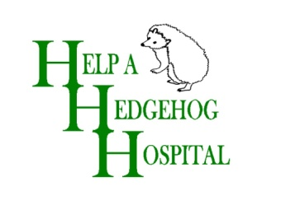

Part A: Membership Form: please return to us

Name:
Address:
Phone number:
Can we send newsletters by email? |  |  |  | Yes / No
Email address:
Membership level:  (Please tick in box as appropriate) |  |  | £25 |  | Family/Couple (delete as applicable)
 |  |  | £15 |  | Adult
 |  |  | £7.50 |  | Junior (under 16)
 |  |  |  |  | For under 16s, please state date of birth
 |  |  | £12.50 |  | Senior
Payment method: |  |  | Cheque enclosed
 |  |  | Bank transfer with your name as a reference
 |  |  | Standing order for a regular monthly donation (please state how much)
 |  |  | Standing order for total membership fee
For cheque payments:
Please return this form and your cheque (made out to Help a Hedgehog Hospital) to:
Maureen Reader, Treasurer, Help a Hedgehog Hospital, The Cottage, Bownham Common, Brimscombe, Stroud, Gloucestershire, GL5 2SN

For Standing orders:
Please complete PART A and return to the address above
Please complete PART B and take to your bank or use online banking to set up your payment.

 - - - - - - - - -  - - - -  - - - - - - - - - - Cut here  - - - - - - - - - - - - - - - - - - - - - - - - -- - - - -

Part B: Standing Order Form: to take to your bank
I would like to set up a Standing order payable to the following, with immediate effect:
Account name: “Help a Hedgehog Hospital”,
Bank name and branch: Lloyds TSB, 12 Rowcroft, Stroud, Gloucestershire, GL5 3BD
Sort code: 30 98 29 Account number: 01145001
Please pay the sum of (tick as appropriate) until cancelled by me in writing:
 | £15.00 | per year (Adult)
 | £25.00 | per year (Family/couple)
 | £12.50 | per year (Senior)
 | £7.50 | per year (Junior/Under 16)
 | £3.00 | per month regular donation
 |  | monthly regular donation (please state how much)

Signed: |  | Date:

